DATE: 10.01.2020
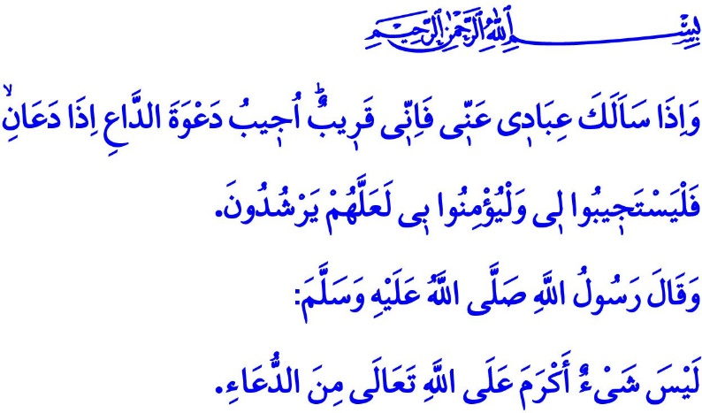SOME DU'AS IN THE WORDS OF PROPHET MUHAMMAD (SAW)
Honorable Muslims!
In this temporary world we have some days we show gratitude for the blessings we are bestowed upon and some other days we show patience for the troubles we have to endure. We try our best to welcome sorrow and hardships as would be appropriate for a Muslim just like we do so when it comes to success and happiness. We are blessed with a unique blessing that strengthen our faith in and reliance upon Allah (swt), gives us hope and a spirit to try better. That blessing is what is the essence of the whole worships: du'a.
It is our sincere entreaty and appeal to Allah (swt). It is our confession that we are weak before His omnipotent power. It is our seeking refuge in His grace and forgiveness. It is our submission of servitude to Him and asking help from Him.
Dear Believers!
In the verse I recited as I began the khutbah the Almighty Allah (swt) states, "And when My servants ask you, o Muhammad, concerning Me - indeed I am near. I respond to the invocation of the supplicant when he calls upon Me. So let them respond to Me by obedience and believe in Me that they may be rightly guided."
One of the names of Allah (swt), al-Mujib, means the answerer of du'as. He is Who is closer to us than even our own self, and hears, knows and responds to all our du'as, whether implied or express.
Dear Muslims!
Prophet Muhammad (saw), in all actions of whom we see his love and loyalty to Allah (swt), was in a constant state of invocation to Him. Day or night, with people around or by himself, when happy, afraid, or sad, when lost in thoughts about the Hereafter, in his home, by the minbar of the masjid, during travel, in short in all instances of life he would make du'a. Du'a in his life was like threads interlaced in a piece of fabric. It was he who taught us how to make du'a.
Waking up in the morning, he would start his day with the following du'a, "O Allah! With Your Power we have come to the morning, with Your Power we come to the evening, with Your Power we live, and we die, and to You will we return."
In observance of the approval of Allah (swt) all day long, he would always rely on and trust in Him, and pray, "O, Allah! Give me what is good for me and choose what is best for me."
"O, Allah! Grant us good both in this world and in the Hereafter. Save us from the torment of of hellfire!" was how he supplicated to Allah (swt).
When by gone is the day and down falls the night, he would pray, "O, Allah! I want from You the good out of what will happen tonight and in its aftermath. I seek refuge in You from the evil of what will happen tonight and in its aftermath."When he would go to sleep, he would pray, "All praise and thanks be to You, Who provides us with food and drink, covers our needs and shelters us while there are countless people who has no place for accommodation and no person to provide for them."
Dear Believers!
Du'a is the servant's search for refuge in Allah (swt) for remedy to sorrows, for protection from all evils, and for safety against troubles whether visible or invisible. In this respect Prophet Muhammad (saw) would seek refuge in Allah (swt) as follows: "O, Allah! Verily, I seek refuge in You from weakness, laziness, senility (of old age), cowardliness, stinginess and the torment of the grave. Give my soul its good and purify it, for You are the best to purify it. You are its Guardian and Master. Verily, I seek refuge in You from a heart that is not humble, a soul that is not satisfied, knowledge that does not benefit and a supplication that is not answered."
Honorable Muslims!
Muslims should never give in to the thought that their supplication is not responded to. In this respect, Prophet Muhammad (saw) states, "The supplication of every one of you will be granted if he does not get impatient and say, 'I supplicated to Allah, but my prayer has not been granted." This is because sometimes Allah (swt) gives us countless blessings for the sake of our du'a. Some other times He takes our troubles away. Sometimes He forgives our sins. Some other times He gives us something better than what we actually want.
Let us then have faith that all our heartfelt du'as will be certainly responded to. Let us not be bereft of abundance of divine blessings, peace, and confidence. Let us not forget to pray for our families, loved ones, Muslim brothers and sisters, and the oppressed, as much as we pray for our own selves. Let us try to deserve the du'a of our parents, the patients, the elderly, and those people in need.
I would like to conclude this khutbah with Prophet Muhammad's (saw) following du'a:

"O, Allah! I ask you to bless me with guidance, piety, chastity, and contentment."

Baqarah, 2/186.
Tirmidhi, Da'wat, 13.
Tirmidhi, Da'wat, 85.
Abu Dawud, Witr, 26.
Muslim, Dhikr, 72.
Tirmidhi, Daawat, 16.
Muslim, Dhikr, 73; Nasa'i, Isti'adha, 13.
Abu Dawud, Witr, 23.
Muslim, Dhikr, 72. General Directorate of Religious Services

